Rupesh Kothari, Sri Seshadri, & Gurjeet Singh

Northwestern University

9/1/2018

MSDS 460 – Final Project – Group 9



**Table of Contents**

**Table of Figures** 1

**Abstract** 2

**Keywords** 2

**Introduction** 3

Background 3

Data Overview 4

Data Exploration 5

**Literature Review** 6

**Methodology** 6

Hybrid approach: 8

**Experiment & Results** 9

**Conclusion** 10

Challenges and limitations 10

Future work: 10

**References** 13

**Appendix** 14

Python Code 14

# **Table of Figures**

Figure 1: Operating Area of Citi Bike 3

Figure 2: Area Selected for Final Project 4

Figure 3: Citi Bike Data 4

Figure 4: Data Exploration 5

Figure 5: New York City bike rebalancing 7

# **Abstract**

Bicycle-sharing systems like the current operations at NYC Citi Bike provide a low-cost, environment-friendly urban transportation option. Efficient management of these systems, which include minimizing cost or maximizing margins and avoiding disappointed customers, poses a bicycle rebalancing problem comprising of three questions: where do bikes need to be, when must they be there, and how can they get there? We apply optimization techniques to yield practical answers to the third question above which is to be minimizing the number of transportation vehicles needed for moving the bikes around and minimizing the distance traveled to fulfil this demand and supply gap at individual stations across the city thereby minimizing the cost of rebalancing.

We utilize Google Optimization Tools (OR-Tools) which is a fast and portable software suite for solving combinatorial optimization problems. It contains algorithms for the Traveling Salesman Problem and Vehicle Routing Problem, and contains Graph algorithms (shortest paths, min cost flow, max flow, linear sum assignment). We do this using Python, but OR-Tools is also available to be used with C++, Java and .Net.

We make assumptions for instantaneous demand and supply on a sample number of bike stations and successfully compute the exact routing solution using Capacitated Vehicle Routing Problems (CVRP) scenario, where the vehicles have constraints on their maximum loads. This involves both picking up vehicles from stations that have an excess supply and delivering vehicles to stations that have an excess demand.

# **Keywords**

Bike sharing, rebalancing, CVRP, VRP

# **Introduction**

Bike sharing is an innovative transportation program, ideal for short distance point-to-point trips providing users the ability to pick up a bicycle at any self-serve bike-station and return it to any other bike station located within the system's operating area. It has recently emerged in major cities around the world, including North America. With the help of technology, bike sharing companies positions bicycles throughout the urban area for immediate access.

To better place themselves in the market and be profitable, bike sharing companies use optimizations concepts to help understand the distribution of the stations across the urban area, find the optimal numbers of bicycles and docks requirement at each station, and proper rebalancing of the bicycles between the stations to prevent loss of revenue. Rebalancing the stations is one of the most challenging, expensive, and resource intensive process. Therefore, we decided to tackle the most challenging problem for our final project.

## Background

For our project, we selected Citi Bike as the bike-sharing company because its data was publically available. Figure 1 shows the operating area of Citi Bike around New York and New Jersey area. The green dots on the map shows that enough bikes available at the stations, yellow dot means bikes are below the required threshold, and the red dot means bikes are out of stock. All the red dots clearly shows that the company is losing the revenue. Therefore, our goal is to optimize the rebalancing process to minimize the cost and increase their revenue. Hence, maximize their profit.

Figure 1: Operating Area of Citi Bike

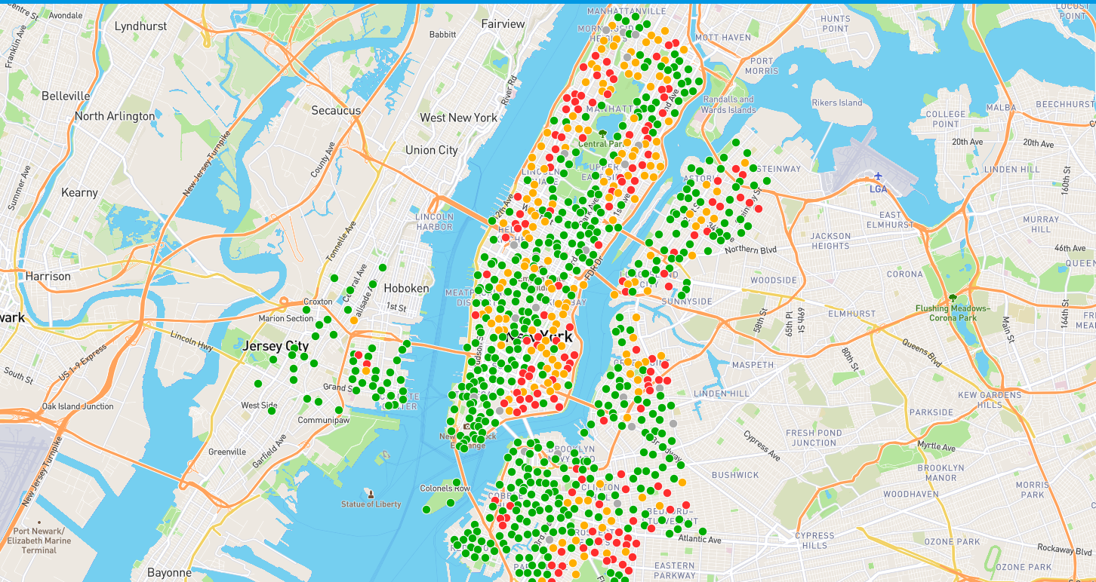

Due to the limitations, we selected the area in New Jersey for our project. This area has about 26 stations. Figure 2 shows the stations and their locations on the map.

Figure 2: Area Selected for Final Project

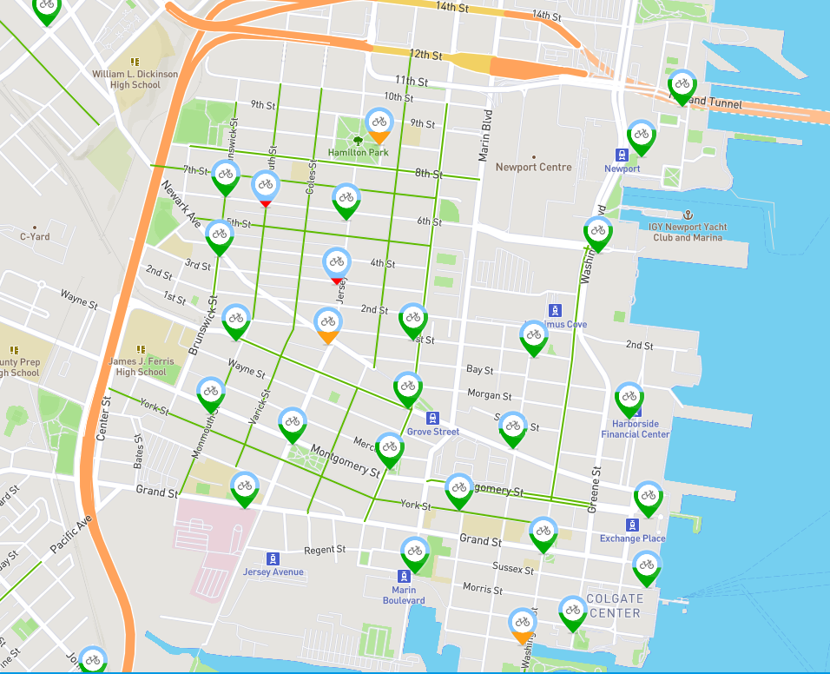

## Data Overview

We used the Citi Bike quarter 2 data. The period includes data from April 1, 2018 to June 30, 2018. Figure 3 shows the snippet of the data. The data provided us with the information such as the to/from the location of the customer ride, when they ride, and how far they go, popular stations, the busiest time of the day and the day of the week. The publically available data did not provide us with demographic information of the customer except customer type, birth year, and gender.

Figure 3: Citi Bike Data

## Data Exploration

Figure 4 shows the various steps taken to understand the data. The first chart (top left) shows the daily miles traveled in quarter 2 (Q2) i.e. April 1st – June 30th. The chart reveals that as the summer approaches, more miles are traveled by the customers. The second chart (top right) shows the daily trips in Q2. Again, we notice that summers are more popular for Citi Bike as more people ride bikes. The third chart (bottom left) shows the number of annual members in Q2. Citi Bike was able to manage more customers during this time. At the end of the quarter, it seems like Citi Bike as over 280K annual members. The last two charts (bottom right and bottom middle) shows the purchases made for 24-hours passes and 3-day passes respectively. Based on the results, it seems in Q2, 24-hour passes are more preferred over 3-days passes.

Figure 4: Data Exploration

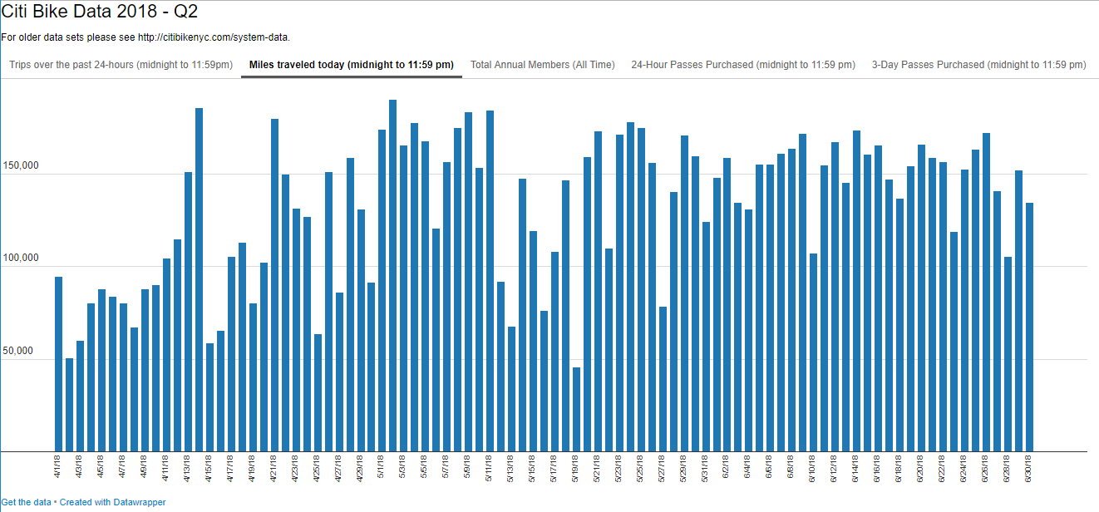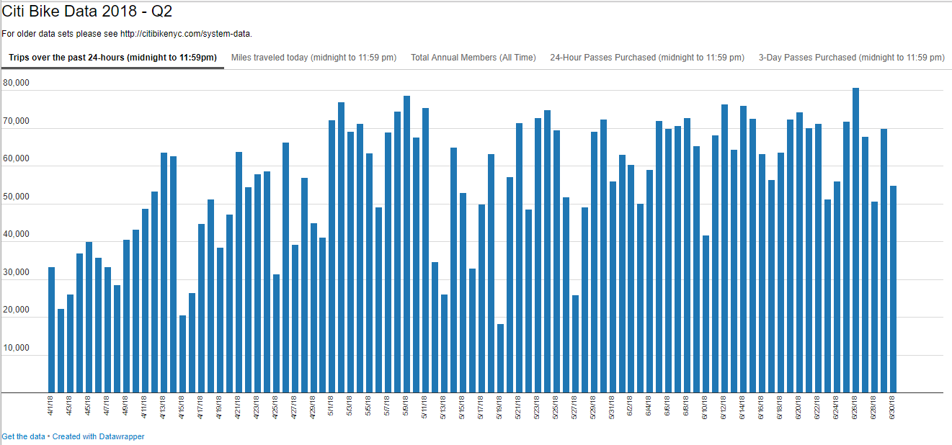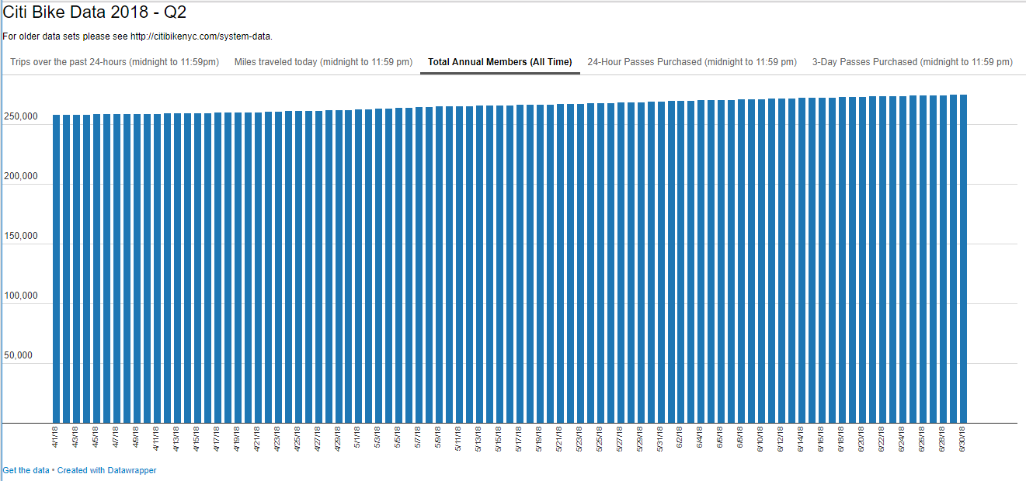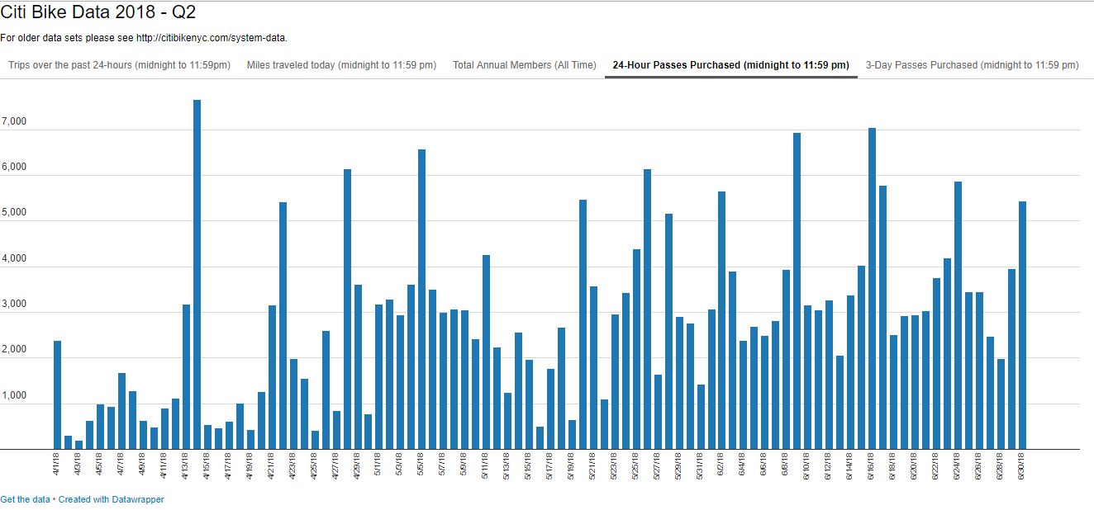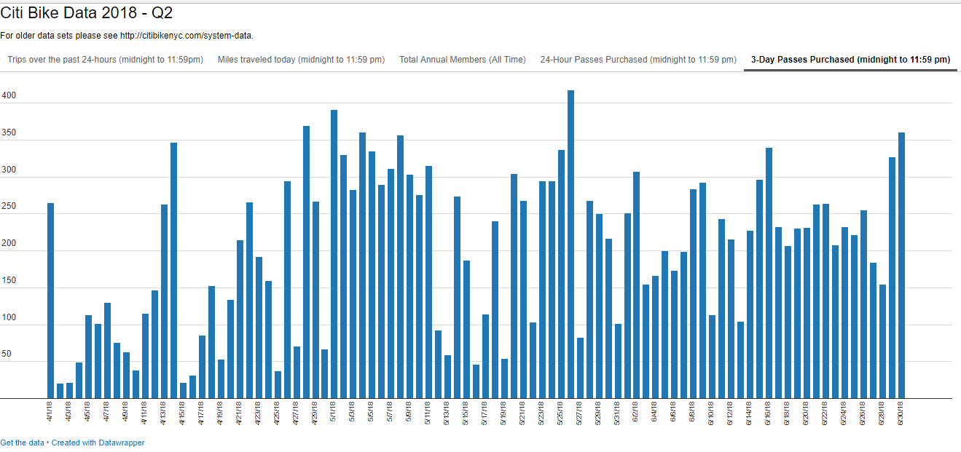

# **Literature Review**

To be added

# **Methodology**

In this section the, modeling of a Capacitated Vehicle Routing Problem(CVRP) is discussed. For this discussion figure 5 below is referenced (“Vehicle Routing - Advanced Topics,” n.d.)

Figure 5: Vehicle Routing Problem illustration



The CVRP is modeled like the Traveling Salesman Problem (TSP), where the ith node (bike station) is characterized by the Cartesian coordinates and demand ⟨xi, yi, di⟩; i ∈ N number of nodes under consideration (N = 0, 1. 2,…,n-1). The node 0 customarily being the depot from which trucks leave from and return to after rebalancing of bikes among different stations or nodes. For V number of vehicles available for the use of rebalancing shall have a capacity of c bikes each. Let Ti be the route taken by each vehicle i∈ V. Ti being a vector of nodes visited by the ith truck. Let dist((S1,S2) be the distance between any two nodes. The distance for this problem is evaluated either by Manhattan distance, which is the sum of horizontal and vertical distances between the nodes or the GPS distances. The Euclidean distances were not considered because the bikes are not transported as the bird flies between two points. The problem can be formulated as :



The first term in the objective function is the distance travelled by truck i∈ V, from the depot to the first node in route Ti . The second term refers to the sum of distances between nodes that the trucks travelled. The last term being the distance from the last node back to the depot. The first constraint impose the capacity constraint and the second constraint impose that each node has only one node going into and out of the node and routes are continuous.

The above formulation is ideal for nodes where trucks pick up bikes and take them to a depot. However, we have a rebalancing problem at hand, where trucks need to pick up excess bikes from nodes that have more than required and deliver it to nodes that need bikes. To ensure that enough bikes are picked up before delivering to a station in need, we impose an additional constraint to the model to the effect of:



It is to be noted that all bikes are treated identical and it does not make a difference which bike is delivered to which station.

The above model was attempted to be solved in ASPE solver in Excel, with a sample of 5 nodes with random negative and positive demand, such that the demands add up to zero. Negative demand indicating demand of bikes and positive demand indicating excess bikes. The model was set up as shown in figure 6 below. The model set up with assumed distances as cost (not Manhattan distances) did not converge to optimal values of cost.

Figure 6 6 ASPE Model



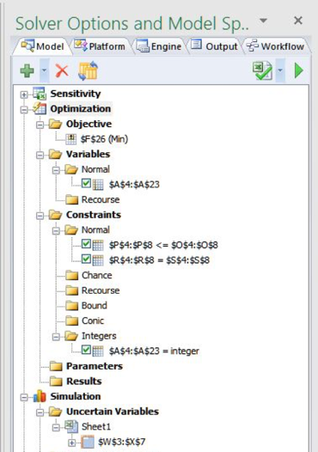

## Hybrid approach:

Further options to solve this problem were explored such as Constraints Programming(CP) to search for a neighborhood of solutions by propagating the constraints to identify feasible solutions space was explored. But given the size of the problem at hand at the amount of time needed for the model to identify optimal routes, the CP approach was abandoned.

Further setting up the model as Mixed Integer Programming model was attempted. The model formulation above was tweaked as below (“Vehicle routing problem,” 2018):



Here too, the objective is to minimize the cost of transportation, where cij is the distance between nodes I and j. xij is a decision variable as a binary variable (1 – indicating a choice to travel between nodes i and j and 0 – indicating a choice not to travel between i and j ). Constaints 1 and 2 impose that only one node enters and leaves a node; constraints 3 and 4 impose all vehicles leaving the depot must return to the depot and constraint 5 impose routes to be continuous and such that vehicle capacity is not exceeded.

To expedite the solution convergence, a combination of neighborhood search heuristic approach along with MIP was explored. Google Optimization platform offers a Python package “ortools”(“Google Optimization Tools | Optimization,” n.d.) was utilized to find an optimal solution. The examples in the ortools documentation webpage was referenced for programming. (“Capacitated Vehicle Routing Problem | Optimization,” n.d.). The code is provided in the Appendix.

# **Experiment & Results**

To obtain an optimal solution at a reasonable amount of time, the number of nodes for the problem was further reduced to 15 nodes (inclusive of the depot). Hypothetical positive and negative demands were generated using random number generator such that the sum of demand adds up to zero. A fleet of 4 trucks each having capacity of truck 15 bikes was assumed.

When the model was presented with Cartesian coordinates (NOT GPS) and Manhattan distances matrix, the model converged to an optimal route; that involves operating only one of the truck (as expected). As seen in figure 7. However, when the model was presented with GPS coordinates of nodes along with google map driving distances that are within 4 miles of each other, (where there was not much separation between the coordinate values) the model did not converge to a solution at a reasonable time. It is hypothesized that applying a scaling factor to the coordinates and limiting the maximum time for solution may further help with solution convergence.

Figure 7 CVRP model result

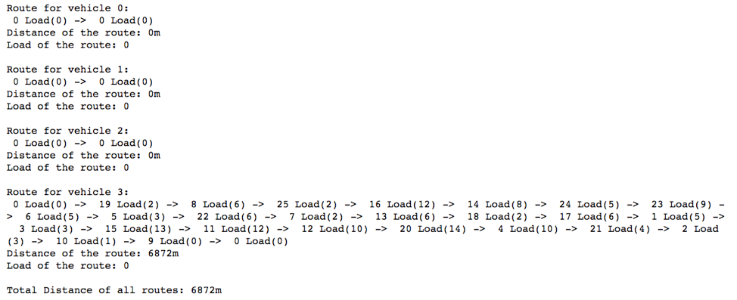

# **Conclusion**

Rebalancing problem is a complex problem and there are several approaches for an optimal solution, such as Constraints Programming, Mixed Integer Programming, Genetic Algorithms, hybrid models using combination of methods. We have searched for an exact solution to the problem, however with relaxation or tolerance on optimal values, a near real time solution could be possible.

## Challenges and limitations

Challenges exist in obtaining a solution at a reasonable time, especially if this is to be used real time several times during a day for rebalancing. One might need sizeable computational power to obtain near exact solutions depending on the choice of model and relaxation.

## Future work:

There are other variations of VRP that can be applied to this situation

Vehicle Routing Problem with Time Windows (VRPTW): The delivery locations have time windows within which the deliveries (or visits) must be made. Vehicle Routing Problem with Multiple Trips (VRPMT): The vehicles can do more than one route. Open Vehicle Routing Problem (OVRP): Vehicles are not required to return to the depot. These models may be appropriate for exploration.

OTHER Figures

1. 26 station nodes selected from the data

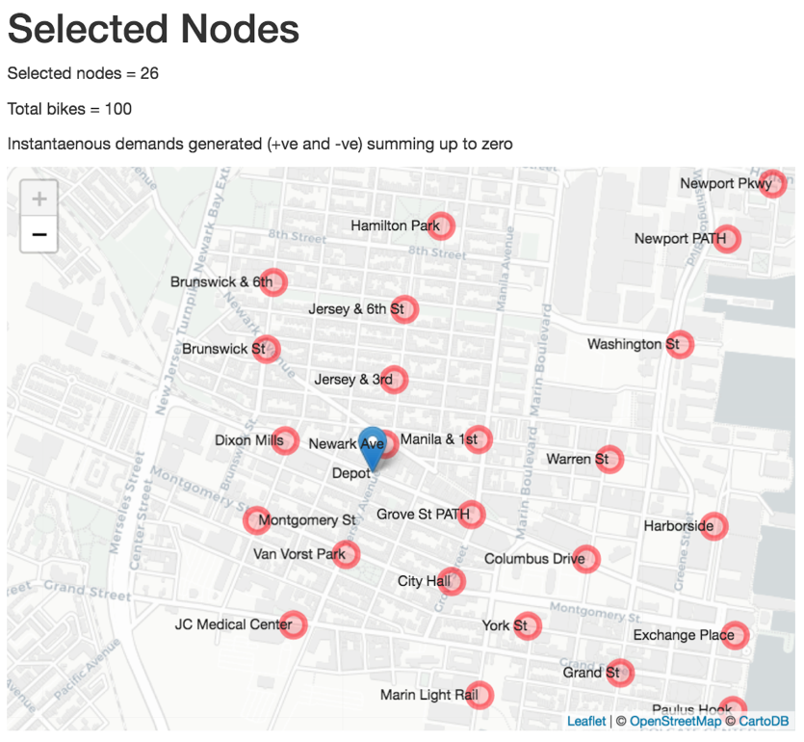

1. Same 26 nodes with one set of demand assumptions

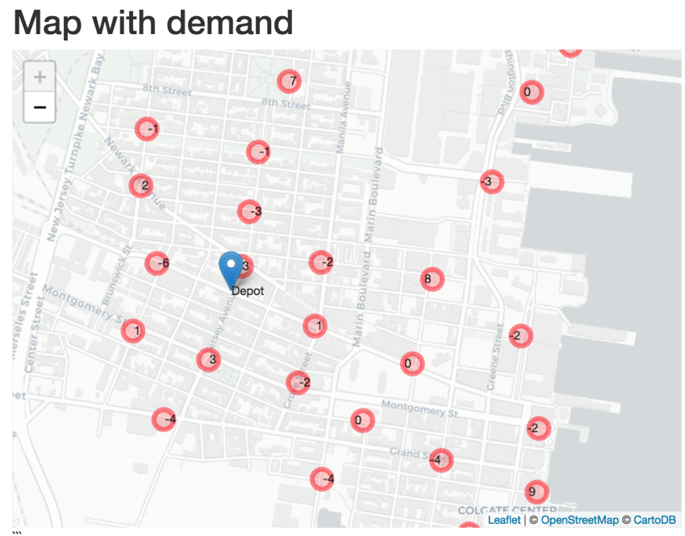

1. Python execution output for above code with one set of assumed demand values

# **References**

Western Michigan University. (2016). Redistribution of the Chicago’s divvy bike-share stations using linear optimization model: *An equity perspective*. Retrieved from https://scholarworks.wmich.edu/cgi/viewcontent.cgi?referer=https://www.google.com/& httpsredir=1&article=1724&context=masters_theses

Cornell University Department of Computer Science. (2015). Data analysis and optimization for (Citi) bike sharing. Retrieved from http://mobility-workspace.eu/wp-content/uploads/Analysis_CitiBikeSharing.pdf

Capacitated Vehicle Routing Problem | Optimization. (n.d.). Retrieved August 31, 2018, from https://developers.google.com/optimization/routing/cvrp

Google Optimization Tools | Optimization. (n.d.). Retrieved August 31, 2018, from https://developers.google.com/optimization/

Vehicle Routing - Advanced Topics: Part I. (n.d.). Retrieved August 30, 2018, from https://www.coursera.org/lecture/discrete-optimization/vehicle-routing-QB8JE

Vehicle routing problem. (2018). In *Wikipedia*. Retrieved from https://en.wikipedia.org/w/index.php?title=Vehicle_routing_problem&oldid=852580999

Dumitrescu, S. R., Cordeau, J. F., & Laporte, G. (2008). The traveling salesman problem with pickup and delivery: *polyhedral results and a branch-and-cut algorithm.* Math. Program. vol. 121, no. 2, p. 269, Jul. 2008.

O’Neil, R. J., & Hoﬀman, K. (n.d.). Exact Methods for Solving Traveling Salesman Problems with Pickup and Delivery in Real Time, 30. Retrieved August 30 2018 from http://www.optimization-online.org/DB_FILE/2017/12/6370.pdf

# **Appendix**

## Python Code

"""Capacitated Vehicle Routing Problem"""

**from** __future__ **import** print_function

**from** six**.**moves **import** xrange

**from** ortools**.**constraint_solver **import** pywrapcp

**from** ortools**.**constraint_solver **import** routing_enums_pb2

###########################

# Problem Data Definition #

###########################

**class** **Vehicle():**

"""Stores the property of a vehicle"""

**def** __init__**(**self**):**

"""Initializes the vehicle properties"""

self**.**_capacity **=** 15

*@property*

**def** capacity**(**self**):**

"""Gets vehicle capacity"""

**return** self**.**_capacity

**class** **CityBlock():**

"""City block definition"""

*@property*

**def** width**(**self**):**

"""Gets Block size West to East"""

**return** 228**/**2

*@property*

**def** height**(**self**):**

"""Gets Block size North to South"""

**return** 80

**class** **DataProblem():**

"""Stores the data for the problem"""

**def** __init__**(**self**):**

"""Initializes the data for the problem"""

self**.**_vehicle **=** Vehicle**()**

self**.**_num_vehicles **=** 4

# Locations in block unit

locations **=** \

**[(**4**,** 4**),** # depot

**(**2**,** 0**),** **(**8**,** 0**),** # row 0

**(**0**,** 1**),** **(**1**,** 1**),** **(**5**,** 2**),** **(**7**,** 2**),** **(**3**,** 3**),** **(**6**,** 3**),** **(**5**,** 5**),** **(**8**,** 5**),**

**(**1**,** 6**),** **(**2**,** 6**),** **(**3**,** 7**),** **(**6**,** 7**),** **(**0**,** 8**),** **(**7**,** 8**),** **(**2**,** 1**),** **(**3**,** 1**),**

**(**5**,** 3**),** **(**1**,** 6**),** **(**7**,** 1**),** **(**3**,** 2**),** **(**8**,** 3**),** **(**7**,** 4**),** **(**6**,** 5**)]**

# locations in meters using the city block dimension

city_block **=** CityBlock**()**

self**.**_locations **=** **[(**

loc**[**0**]\***city_block**.**width**,**

loc**[**1**]\***city_block**.**height**)** **for** loc **in** locations**]**

self**.**_depot **=** 0

self**.**_demands **=** \

**[**0**,** **-**1**,** **-**1**,** **-**2**,** **-**4**,** **-**2**,**

**-**4**,** **-**4**,** 4**,** **-**1**,** **-**2**,** **-**1**,**

**-**2**,** 4**,** **-**4**,** 10**,** 10**,** 4**,**

**-**4**,** 2**,** 4**,** **-**6**,** 3**,** 4**,**

**-**3**,** **-**4**]**

*@property*

**def** vehicle**(**self**):**

"""Gets a vehicle"""

**return** self**.**_vehicle

*@property*

**def** num_vehicles**(**self**):**

"""Gets number of vehicles"""

**return** self**.**_num_vehicles

*@property*

**def** locations**(**self**):**

"""Gets locations"""

**return** self**.**_locations

*@property*

**def** num_locations**(**self**):**

"""Gets number of locations"""

**return** len**(**self**.**locations**)**

*@property*

**def** depot**(**self**):**

"""Gets depot location index"""

**return** self**.**_depot

*@property*

**def** demands**(**self**):**

"""Gets demands at each location"""

**return** self**.**_demands

#######################

# Problem Constraints #

#######################

**def** manhattan_distance**(**position_1**,** position_2**):**

"""Computes the Manhattan distance between two points"""

**return** **(**abs**(**position_1**[**0**]** **-** position_2**[**0**])** **+**

abs**(**position_1**[**1**]** **-** position_2**[**1**]))**

**class** **CreateDistanceEvaluator(**object**):** # pylint: disable=too-few-public-methods

"""Creates callback to return distance between points."""

**def** __init__**(**self**,** data**):**

"""Initializes the distance matrix."""

self**.**_distances **=** **{}**

# precompute distance between location to have distance callback in O(1)

**for** from_node **in** xrange**(**data**.**num_locations**):**

self**.**_distances**[**from_node**]** **=** **{}**

**for** to_node **in** xrange**(**data**.**num_locations**):**

**if** from_node **==** to_node**:**

self**.**_distances**[**from_node**][**to_node**]** **=** 0

**else:**

self**.**_distances**[**from_node**][**to_node**]** **=** **(**

manhattan_distance**(**

data**.**locations**[**from_node**],**

data**.**locations**[**to_node**]))**

**def** distance_evaluator**(**self**,** from_node**,** to_node**):**

"""Returns the manhattan distance between the two nodes"""

**return** self**.**_distances**[**from_node**][**to_node**]**

**class** **CreateDemandEvaluator(**object**):** # pylint: disable=too-few-public-methods

"""Creates callback to get demands at each location."""

**def** __init__**(**self**,** data**):**

"""Initializes the demand array."""

self**.**_demands **=** data**.**demands

**def** demand_evaluator**(**self**,** from_node**,** to_node**):**

"""Returns the demand of the current node"""

**del** to_node

**return** self**.**_demands**[**from_node**]**

**def** add_capacity_constraints**(**routing**,** data**,** demand_evaluator**):**

"""Adds capacity constraint"""

capacity **=** "Capacity"

routing**.**AddDimension**(**

demand_evaluator**,**

0**,** # null capacity slack

data**.**vehicle**.**capacity**,** # vehicle maximum capacity

**True,** # start cumul to zero

capacity**)**

###########

# Printer #

###########

**class** **ConsolePrinter():**

"""Print solution to console"""

**def** __init__**(**self**,** data**,** routing**,** assignment**):**

"""Initializes the printer"""

self**.**_data **=** data

self**.**_routing **=** routing

self**.**_assignment **=** assignment

*@property*

**def** data**(**self**):**

"""Gets problem data"""

**return** self**.**_data

*@property*

**def** routing**(**self**):**

"""Gets routing model"""

**return** self**.**_routing

*@property*

**def** assignment**(**self**):**

"""Gets routing model"""

**return** self**.**_assignment

**def** **print(**self**):**

"""Prints assignment on console"""

# Inspect solution.

total_dist **=** 0

**for** vehicle_id **in** xrange**(**self**.**data**.**num_vehicles**):**

index **=** self**.**routing**.**Start**(**vehicle_id**)**

plan_output **=** 'Route for vehicle {0}:\n'**.**format**(**vehicle_id**)**

route_dist **=** 0

route_load **=** 0

**while** **not** self**.**routing**.**IsEnd**(**index**):**

node_index **=** self**.**routing**.**IndexToNode**(**index**)**

next_node_index **=** self**.**routing**.**IndexToNode**(**

self**.**assignment**.**Value**(**self**.**routing**.**NextVar**(**index**)))**

route_dist **+=** manhattan_distance**(**

self**.**data**.**locations**[**node_index**],**

self**.**data**.**locations**[**next_node_index**])**

route_load **+=** self**.**data**.**demands**[**node_index**]**

plan_output **+=** ' {0} Load({1}) -> '**.**format**(**node_index**,** route_load**)**

index **=** self**.**assignment**.**Value**(**self**.**routing**.**NextVar**(**index**))**

node_index **=** self**.**routing**.**IndexToNode**(**index**)**

total_dist **+=** route_dist

plan_output **+=** ' {0} Load({1})\n'**.**format**(**node_index**,** route_load**)**

plan_output **+=** 'Distance of the route: {0}m\n'**.**format**(**route_dist**)**

plan_output **+=** 'Load of the route: {0}\n'**.**format**(**route_load**)**

**print(**plan_output**)**

**print(**'Total Distance of all routes: {0}m'**.**format**(**total_dist**))**

########

# Main #

########

**def** main**():**

"""Entry point of the program"""

# Instantiate the data problem.

data **=** DataProblem**()**

# Create Routing Model

routing **=** pywrapcp**.**RoutingModel**(**data**.**num_locations**,** data**.**num_vehicles**,** data**.**depot**)**

# Define weight of each edge

distance_evaluator **=** CreateDistanceEvaluator**(**data**).**distance_evaluator

routing**.**SetArcCostEvaluatorOfAllVehicles**(**distance_evaluator**)**

# Add Capacity constraint

demand_evaluator **=** CreateDemandEvaluator**(**data**).**demand_evaluator

add_capacity_constraints**(**routing**,** data**,** demand_evaluator**)**

# Setting first solution heuristic (cheapest addition).

search_parameters **=** pywrapcp**.**RoutingModel**.**DefaultSearchParameters**()**

search_parameters**.**first_solution_strategy **=** **(**

routing_enums_pb2**.**FirstSolutionStrategy**.**PATH_CHEAPEST_ARC**)**

# Solve the problem.

assignment **=** routing**.**SolveWithParameters**(**search_parameters**)**

printer **=** ConsolePrinter**(**data**,** routing**,** assignment**)**

printer**.print()**

**if** __name__ **==** '__main__'**:**

main**()**